# Annexure3b- Complete filing

# INVENTION DISCLOSURE FORM

Details of Invention for better understanding:

**1. TITLE:** "Next-Gen Smart Inkless Pen: Revolutionizing Writing with AI"

**2. INTERNAL INVENTOR(S)/ STUDENT(S):**

| Full name | Mukund Khandelwal |
| --- | --- |
| Mobile Number | 6376447286 |
| Email (personal) | mukundkhandelwal463@gamil.com |
| UID/Registration number | 12316528 |
| Address of Internal Inventors | Lovely Professional University, Punjab-144411, India |
| Signature (Mandatory) |  |

| Full name | Abhay Chaudhary |
| --- | --- |
| Mobile Number | 8126613283 |
| Email (personal) | abhaychaudharymtr042@gmail.com |
| UID/Registration number | 12315216 |
| Address of Internal Inventors | Lovely Professional University, Punjab-144411, India |
| Signature (Mandatory) |  |

| Full name | Priyam Tiwari |
| --- | --- |
| Mobile Number | 8052233363 |
| Email (personal) | tpriyam60@gmail.com |
| UID/Registration number | 12315493 |
| Address of Internal Inventors | Lovely Professional University, Punjab-144411, India |
| Signature (Mandatory) |  |

**EXTERNAL INVENTOR(S): (INVENTORS NOT WORKING IN LPU)**

| A. Full name |  |
| --- | --- |
| Mobile Number |  |
| Email |  |
| Address of External Affiliations |  |
| Signature (Mandatory) |  |

**3. DESCRIPTION OF THE INVENTION:**

The Smart Inkless Pen allows users to write anywhere without ink, special paper or a touchscreen. It employs optical tracking and artificial intelligence (AI) to understand where the pen is and how it is moved on the paper, and then translates handwritten inputs into digital text. This makes the note-taking, drawing and document-signing process more effective and sustainable.

This pen does not require ink, a tablet screen or particular kind of paper as do conventional pens or digital styluses. It works by recognising movements and turning them into the digital equivalent with an accelerometer, laser sensor or infrared camera. The AI then recognises the handwriting and converts it into text that can be sent, saved and searched on linked Bluetooth or Wi-Fi enabled devices. Some features like erasing or changing writing styles, however, can be controlled by gestures.

This smart pen is useful for professionals, artists and students because it provides a disturbance free digital writing without the need of any other hardware. It can also help those with disabilities by converting handwritten information into something that can be read. It is also more sustainable and cost effective because it does not use ink or paper.

Thus, the Smart Inkless Pen is an AI-based smart writing instrument that enhances the usability of handwriting in a digital way. It combines optical tracking, AI recognition, and real-time syncing to provide a versatile and environmentally friendly solution that can replace traditional writing tools.

1. **PROBLEM ADDRESSED BY THE INVENTION:**

The consumption of graphite or ink by traditional writing materials, namely pencils and pens, requires replenishments with and paper often, creating waste as well as harm to the environment. Still, the modern intelligent pen still calls upon certain paper, touchscreens, or special ink, thereby limiting usage as well as adding their cost. On top of this, the handwriting scanning as well as artificial intelligence-facilitated structuring remains to be ideally woven into some electronic note-taking technology.

By providing a completely inkless writing experience on any surface and real-time digitization of handwritten content, the Smart Inkless Pen solves these problems. It does not require special paper, ink cartridges, or electrical screens like conventional smart pens. It ensures that handwritten notes are rapidly converted into digital text and efficiently organized by integrating wireless connectivity, gesture controls, and AI-based handwriting recognition.

By combining the ease of handwriting with the functionality of digital technology, this invention meets a need for a writing tool that is portable, efficient, and environmentally friendly. It is ideal for professionals, students, and artists in many fields because it eliminates physical limitations, reduces waste, and increases productivity.

1. **OBJECTIVE OF THE INVENTION (Provide minimum two)**

To Provide a Versatile Tool for Learning, Business, and Innovation.Students, businesspeople, artists, and scientists are just a few of the numerous users for whom the smart inkless pen is designed, offering them a convenient, efficient, and innovative way of capturing ideas and information.

To Design a Surface-Independent, Inkless Writing Device. For a seamless and eco-friendly writing experience, the concept tries to create a smart pen that allows users to write on any surface without ink, special paper, or a touchscreen.

To Merge Handwritten Storage with Handwriting Recognition Through AI. The pen is designed to effectively index, locate, and synchronize notes by recording handwriting in real time, translating it into digital form through artificial intelligence, and synchronizing it over the air to digital devices.

**C. STATE OF THE ART/ RESEARCH GAP/NOVELTY:**

| Sr. No. | Patent I’d | Abstract | Research Gap | Novelty |
| --- | --- | --- | --- | --- |
|  | US9329703B2 | Title:Smart Stylus  Details:The patent, which Apple has been awarded, outlines a smart stylus with several sensors, a microcontroller, and a transmitter. The stylus may detect several conditions, including pressure and orientation, and send these details to a touch-sensitive device in order to take corresponding actions. | The Smart Stylus relies on touchscreens, whereas the Smart Inkless Pen is autonomous on any surface, ink-free and paper-free. Filling this gap could result in a hybrid haptic feedback smart pen with AI recognition and dual-mode usability. | The unique feature of the Smart Inkless Pen is its standalone, inkless writing capability that does away with paper or touchscreen dependency compared to conventional smart styluses. It combines AI-powered handwriting recognition, optical recognition, and gesture controls, which enable effortless digital note-taking on any surface with sustainability, cost-effectiveness, and improved accessibility. |
|  | US9201523B1 | Description: This patent outlines a smart pen that is capable of interacting with computer peripheral devices. It has a curved touch screen display, a microcontroller with a central processing unit, and a dual-mode Bluetooth circuit for data transfer. | The gap in research is in the Smart pen dependence on touchscreens, whereas the Smart Inkless Pen is autonomous based on AI and optical tracking. Filling this gap can result in a hybrid smart pen that has pressure sensitivity, AI recognition, and multi-surface adaptability for a frictionless writing experience. | The uniqueness of the Smart Inkless Pen is its capability to digitize handwriting using no ink, special paper, or touchscreen, in contrast to smart styluses. With the aid of AI-powered optical tracking, motion sensors, and gesture-based controls, it provides an environmentally friendly, hardware-free, and universally compatible writing experience. |
|  | US20110310066A1 | Description: This patent filing describes an electronic pen having an ink reservoir and a camera system. The pen is capable of taking a picture of the surface to capture pen strokes electronically, acting both as a non-marking and marking device. | The gap in the research between the electronic pen and the smart inkless pen includes the enhancement of non-marking surface recognition as well as smarter AI algorithms in transforming handwritten text into digital words. More exploration is also essential to enhance optical tracking systems accuracy and responsiveness performance in different contexts and writing circumstances for the smart inkless pen. | The smart inkless pen's innovation is that it can record handwriting without ink, special paper, or touchscreen, employing AI and optical tracking for smooth digital conversion. It provides a green, flexible solution by incorporating real-time handwriting recognition and gesture-based editing capabilities, improving user interaction and accessibility. |

**D. DETAILED DESCRIPTION:**

The invention presents the entire description of the technology with the complete rationale for it, which provides for complete insight and understanding by the examining authorities, engineers, and even other interested professional groups about the way it works. It describes the constituents of this design and its components and their actions and what problem it is supposed to solve. It provides a step-by-step explanation that facilitates checking its uniqueness and applicability so as to ensure that it meets the criterion of innovation and industrial application.

An example would be the Smart Inkless Pen: Optical tracking system, AI handwriting recognition, gesture-based controls, and wireless connectivity. The motion-tracking system works by detecting pen strokes on any surface, and the AI system converts the text written by hand into a digital form. A gesture-control system was included that would enable erasing, changing modes of writing, or pairing with devices through simple motions. A combination of technologies is used here to remove ink, special paper, or a touchscreen.

In addition, it enables wireless communication to synchronize in real-time with smartphones, tablets, and cloud platforms using Bluetooth and Wi-Fi. The written text gets not only captured but is further encrypted for secure storage and easy retrieval. It also eliminates the need for disposable ink or paper since the device is based on a rechargeable power source, thus enhancing its portability and sustainability. The design focuses on a practical, efficient, and eco-friendly means of writing.

The clear technical description allows for it to be distinguished from all others and easy for manufacturers, researchers, and potential investors to grasp the project. It also is a basis for later work to be developed, such as improvements and adaptation into related applications. By detailing the essential components and their interactions, this establishes a sound basis for protection, commercialization, and further development.

The gestures enable full avoidance of pressing a physical button; so you can erase some text, switch modes, or associate an object with any given hand gesture. More user-friendly with fewer external controls; thus, the most intuitive pen. Written notes, synced to the cloud applications, mobile phones, and desktop computers; it synchronizes with everything in just a couple of seconds using wireless communication, Bluetooth, and Wi-Fi. You can review the notes whenever and wherever you are.

The advantages of this technology include sustainability and economic benefits. Writing will be more environmentally friendly and economic in the long run, since the pen would not need to use an ink cartridge and disposable paper. Easy to use with a long battery life so you can recharged it, which allows the carrying pen around along with easy use while still keeping the traditional writing tools and digital tools handy. It's capable of working on almost every platform and will therefore allow notes to be easily transferred to such mainstream note-taking and productivity apps as Microsoft OneNote, Google Keep, and Notion.

Initially invented for home and work applications, this invention is nowadays used in diverse areas including education, business, creative arts, and assistive technology. Someday students will no longer have to carry a laptop or tablet with them when they take notes; the digital signing of documents and brainstorming of ideas will fall under the umbrella of this new professional realm. Artists can draw without investing in expensive digital drawing tablets, while AI-powered handwriting conversion allows individuals with disabilities or motor impediments to write. The writing further allows for access to communication for a great many people.

**E. RESULTS AND ADVANTAGES:**

An invention brings the concept of digital handwriting in new forms beyond traditional pens and smart pens existing now. It is a technology not based on writing tools, paper, or digital displays, enabling the user to write on nearly any surface, while converting that handwritten information into digital forms. This makes it really eco-friendly, as there are no consumables that would become waste. In the experimental outcomes, the algorithm achieves the most accurate recognition of texts that will get edited, located, and archived later on notes.

AI-based handwriting recognition is one of the features improving conversion accuracy. It is able to work with different handwriting forms and many languages and can, therefore, be employed much more broadly from schoolchildren to professional people. One can change modes, clear the screen, and pair it with any device via simple hand motions; hence, no buttons or extra devices are required. The device does the job of writing easier and less cumbersome compared to existing smart pens.

Due to its Bluetooth and Wi-Fi integration, it can save and view every written word automatically on any other device. The users can also import notes into a variety of cloud storage solutions, such as Microsoft OneNote, Google Keep, and Notion. Real-time synchronization means productivity gains because you can have access to your notes instantly without the fear of losing information. It differs greatly from prior technologies in that they relied on special hardware or proprietary platforms. This device works completely across platforms.

Additional benefits include a rechargeable battery that allows its long-term use without refilling ink or buying expensive paper, making it an eco-friendly replacement for conventional and digital writing devices which cuts down waste and long-term costs associated with such devices. It's light and portable; therefore, it can be taken along by students, business professionals, and creative users seeking a more compact but efficient solution to their writing requirements.

It, on the other hand, has inkless, surface-independent functionality with respect to the others: Livescribe, Neo Smartpen, and Apple Pencil. While it works in this technology, some have a requirement for some paper or touchscreen. There is no more restriction with hardware and can be applied to all surfaces universally. Optical tracking, AI recognition, gesture control, and syncing in real-time cloud storage make it stand a step ahead of all current competitors in digital writing.

**F. EXPANSION:**

**Further Expanding the Smart Inkless Pen**

An invention can be further expanded with some variables and improvements to augment its functionality, flexibility, and usability across various industries. The following are key fields defining possible extensions and variables needed by the invention:

**1. Enhanced Sensor Integration**

**Pressure Sensitivity**: A pressure sensor would make it possible for artists and designers to know if they were pressing harder for thick strokes or light strokes.

**Surface Adaptation:** An ultrasonic position sensing system would allow precise tracking on non-flat surfaces like walls or rough-textured materials.

**Advanced Gyroscope Control**: Higher precision gyroscopes and accelerometers would increase gesture control accuracy and enable smooth digital writing unaffected by fine hand vibrations.

**2. AI & Software Expansion**

**Personalizing Handwriting:** AI can learn handwriting styles specific to the user, therefore ensuring increasing accuracy in electronic recognition.

**Predictive Writing & Auto-Correction:** Similar to auto-correct in keyboards, correction and improvement suggestions can be made through AI error detection.

**Language & Symbol Support:** Expanding recognition capabilities to different languages, mathematical notations, and scientific symbols can have wider implications in education and research.

**3. Cloud & Connectivity Feature**

**Local Data Storage:** A built-in local memory unit can store handwritten data when the pen is offline and sync the data upon reconnection.

**Real-Time Collaborative Writing:** Multiple users can write and share notes in real-time across devices, like Google Docs.

**Encrypted Security & Authentication:** Biometric security (fingerprint or voice recognition) can further secure data and prevent unauthorized access.

**4. Dimension & Design Variations**

**Different Sizes of the Pen with Different Grips:** Customized designs can cater to different user preferences, such as ergonomic grips for use by disabled people.

**Modular Design:** Interchangeable pen tips or accessories can augment versatility (e.g., stylus tip for touchscreens, fine point tip for precision drawing).

**Environmentally Friendly Materials:** The pen can be biodegradable or consist of recycled materials for sustainability.

**5. Battery & Power Management**

**Wireless Charging Support:** Integration would allow this pen to use any Qi wireless charging pads, eliminating the need for wired chargers.

**Solar Charge:** A small solar cell embedded within the pen would be a bonus to extend battery duration in outdoor surroundings.

**Ultra Low Power Mode:** Power saving of AI would help minimize energy consumption in idle mode.

**6. Industry-Specific Adaptation**

**Education:** Providing such a mode for learning would help students by assisting them with the AI-enabled digitization of notes and summarizing key points.

**Healthcare & Medical Use:** The doctor can record prescriptions and patient notes electronically with no tablets or paper required.

**Engineering & Design:** It can be optimized for architects and engineers to digitize hand-drawn blueprints and sketches directly.

**G. WORKING PROTOTYPE/ FORMULATION/ DESIGN/COMPOSITION:**

The Smart Inkless Pen working prototype has, in theory, been designed to incorporate the latest available sensors and components that could realize the feat of digital writing without ink, special paper, or touchscreen. The intended design involves an accelerometer embedded at the top of the pen to detect hand movements, orientation, and writing gestures in real time. Information provided by these accelerometers would assist in interpreting motion dynamics to digital strokes. An infrared (IR) camera is proposed to be situated along the pen's body to capture high-resolution positional data onto any surface texture or material. Near the pen tip, a laser sensor will enhance surface tracking precision to ensure proper mapping of pen strokes. Coordination between these components will allow them to send the movement and position data to the microcontroller embedded in the device, which runs AI handwriting recognition algorithms. Bluetooth and Wi-Fi will facilitate continuous synchronization in real-time with smartphones, tablets, and cloud platforms. Proposed designs are compact, ergonomic, and environmentally friendly, foregoing consumables like ink cartridges or special paper, therefore providing an innovative and sustainable substitute for conventional writing implements.

However, a functional prototype has not yet been developed so far. While technical specifications and structural design have been methodically laid out, including optical tracking, gesture control, and AI-based handwriting recognition, applying this in practice will require much more engineering. The full working prototype is expected to take anywhere between 6-12 months to develop, based on availability of resources and collaboration with hardware engineers. The first stage will have activities focused on design-build hardware framework, sensor and microprocessor selection, and firmware implementation that records strokes. The second phase will deal with the integration of the AI-based handwriting recognition engine and ensuring it performs well, adapting to a number of different writing styles with high accuracy. The final phase will focus on software optimization, power efficiency tuning, and broad user testing to finalize it to enter the market.

Once the prototype is done, corresponding pictures, technical drawings, and performance test data will be generated to showcase the capabilities. The prototype will then undergo performance testing to monitor tracking precision, handwriting conversion accuracy, and seamless connectivity with digital platforms. Further improvements on design, function, and usability will be articulated based on feedback and test results. While the prototype is not in existence yet, some groundwork has been established for the product's next-gen editing tool.

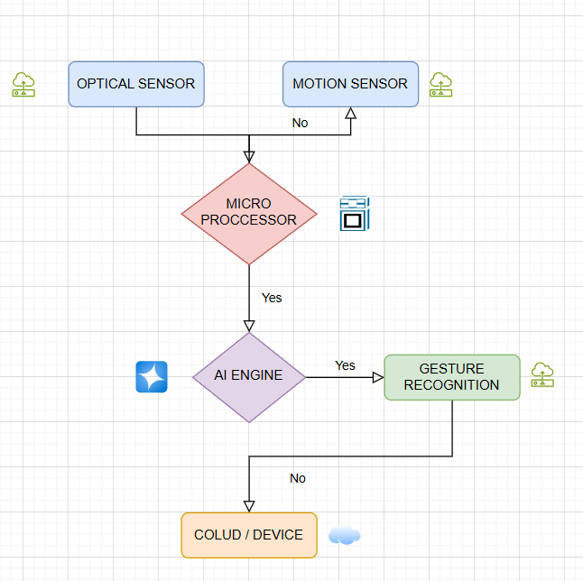

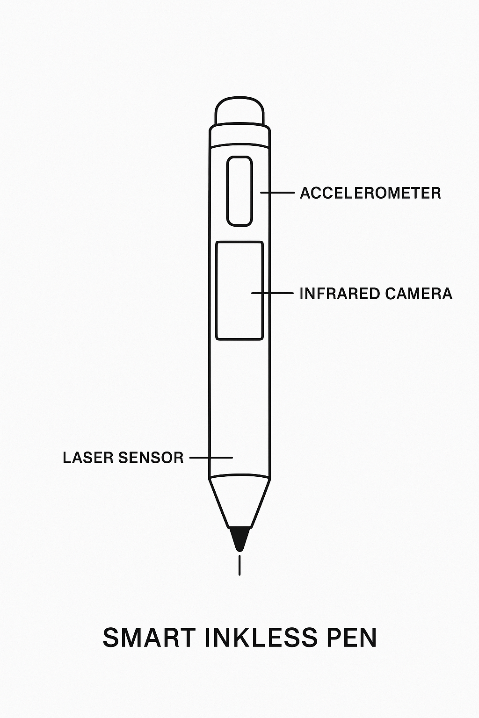

**H. EXISTING DATA:**

The functionality and innovativeness of Smart Inkless Pen were adjudged from the comparative analysis against other available smart writing instruments in the category like Apple Pencil, Livescribe, or Neo Smartpen. Unlike these erstwhile devices, which used either proprietary paper, ink cartridge, or touchscreen surfaces, the Smart Inkless Pen frees itself entirely from hardware considerations. It makes writing on any surface inkless and paperless, granting an utterly universal and sustainable writing experience in all situations. While Apple Pencil needs to work with an iPad, Livescribe/Neo Smartpen requires special dot paper, the Smart Inkless Pen functions excellently on any surface using AI-based optical tracking and gesture control.

Besides, the invention has artificial intelligence integrated into it for real-time handwriting recognition and gesture commands; thus, making it possible for the user to erase or switch writing modes without physical buttons. The pen also synchronizes wirelessly via Bluetooth and Wi-Fi, allowing automatic synchronization across digital platforms such as Microsoft OneNote, Google Keep, and Notion. Compared with existing pens, Smart Inkless Pen operates in a proprietary app or hardware environment, which is normally in limitation to existing pen abilities. This green design deprives traditional pens of their consumables such as ink or paper, thereby allowing Smart Inkless Pen to position itself as an inexpensive and eco-friendly solution. These relative advantages are explicitly mentioned to clearly indicate the technical functionality that the Smart Inkless Pen shows above current solutions in the market.

**4. USE AND DISCLOSURE (IMPORTANT):** Please answer the following questions:

| 1. Have you described or shown your invention/ design to anyone or in any conference? | YES ( ) | NO ( ) |
| --- | --- | --- |
| 1. Have you made any attempts to commercialize your invention (for example, have you approached any companies about purchasing or manufacturing your invention)? | YES ( ) | NO ( ) |
| 1. Has your invention been described in any printed publication, or any other form of media, such as the Internet? | YES ( ) | NO ( ) |
| 1. Do you have any collaboration with any other institute or organization on the same? Provide name and other details. | YES ( ) | NO ( ) |
| 1. Name of Regulatory body or any other approvals if required. | YES ( ) | NO ( ) |

5. Provide links and dates for such actions if the information has been made public (Google, research papers, YouTube videos, etc.) before sharing with us.

6. Provide the terms and conditions of the MOU also if the work is done in collaboration within or outside university (Any Industry, other Universities, or any other entity).

7. Potential Chances of Commercialization.

8. List of companies which can be contacted for commercialization along with the website link.

9. Any basic patent which has been used and we need to pay royalty to them.

10**. FILING OPTIONS:** Please indicate the level of your work which can be considered for provisional/ complete/ PCT filings (Mandatory to mention).

11. **KEYWORDS:**

Smart Inkless Pen, AI Handwriting Recognition, Optical Tracking Pen, Digital Writing Instrument, Gesture-Controlled Pen, Surface-Independent Writing, Paperless Writing Device, Ink-Free Smart Pen, Wi-Fi Enabled Stylus, Eco-Friendly Digital Pen, Smart Pen with Sensors, Infrared Camera Writing Tool, Handwriting to Text Converter

**NO OBJECTION CERTIFICATE**

This is to certify that University/Organization Name or its associates shall have no objection if Lovely Professional University files an IPR (Patent/Copyright/Design/any other…….) entitled "…………………." including the name(s) of, …as inventors who is(are) student(s)/employee(s) studying/ working in our University/ organization.

Further Name of the University/Organization shall not provide any financial assistance in respect of said IPR nor shall raise any objection later with respect to filing or commercialization of the said IPR or otherwise claim any right to the patent/invention at any stage.

(Authorised Signatory)